MODEL DESIGN — KIDNEY TRANSPLANT LOGISTICS &
PERISHABLE QUEUEING SIMULATION

- OVERVIEW

The simulation model represents a kidney transplant system where two types of entities — donor kidneys and waitlisted patients — flow through a network of processes that mirror real-world organ procurement, matching, testing, transportation, and surgical transplantation. The distinguishing feature of this model is that kidneys are perishable entities subject to a cold ischemia clock that begins at harvest and imposes a hard 36-hour viability deadline with continuous exponential quality decay.

The model is built using an Arena-equivalent discrete-event simulation framework (SimPy) and is structured entirely around Arena's core module types: Create, Assign, Decide, Process (Seize-Delay-Release), Hold/Queue, and Dispose.

- ENTITIES

The model has two entity types, each with a set of Arena-style attributes:

ENTITY 1 — KidneyOrgan (Perishable)

An organ entity that enters the system upon donor procurement. Each kidney
carries the following attributes:
• Entity ID — Unique serial number
• Blood Type — ABO group (O, A, B, AB), sampled from US population
distribution (O: 44%, A: 42%, B: 10%, AB: 4%)
• HLA Profile — 6-antigen tissue typing (each antigen randomly 1–20)
• Donor Type — "Deceased" or "Living"
• Harvest Time — Simulation clock time when the organ was procured
• Quality Score — Starts at 1.0 and decays via Q(t) = e^(-0.05·t)
• Max Viable Time — 36 hours (cold ischemia limit)
• Transport Zone — Local, Regional, or National
• Status — Tracks position in flowchart (Harvested, In Pool,
Matched, Crossmatch Testing, In Transport, In Surgery,
Transplanted, Expired, Rejected)

ENTITY 2 — Patient (Wait listed)

A patient entity that enters the transplant waitlist. Attributes include:
• Entity ID — Unique serial number
• Blood Type — ABO group (same distribution as kidneys)
• HLA Profile — 6-antigen tissue typing
• Urgency Level — UNOS-style: Critical (10%), High (25%),
Medium (40%), Low (25%)
• Time on Waitlist — Clock time when patient joined the list
• Age — Uniformly sampled between 18–75 years
• PRA — Panel Reactive Antibody percentage (0–100%);
higher values indicate sensitized patients who are
harder to match
• Priority Score — Composite: (Urgency Weight × 10) + (Wait Days × 0.5)
+ (PRA/100 × 5)
• Status — Waiting, Matched, Transplanted, Died Waiting,
Transferred

- MODULES USED

The simulation model is designed using the following Arena-equivalent modules:

MODULE 1 — CREATE: Deceased Donor Kidney Arrivals
Generates kidney organ entities representing deceased-donor procurement events. Inter-arrival times follow an Exponential distribution with a rate of 1/8 per hour (approximately 3 kidneys per day). Upon creation, each kidney entity is assigned randomized blood type, HLA profile, and donor type attributes. The cold ischemia clock starts immediately at creation time.

MODULE 2 — CREATE: Patient Arrivals to Waitlist
Generates patient entities who need a kidney transplant. Inter-arrival times follow an Exponential distribution with a rate of 1/4 per hour (approximately 6 patients per day). Each patient is assigned a randomized blood type, HLA profile, urgency level, age, and PRA sensitization score. Upon creation, the patient entity enters the waitlist queue and also triggers a check of the organ pool to see if any currently available kidney is compatible.

MODULE 3 — CREATE: Living Donor Kidney Arrivals
Generates pre-scheduled living donor kidney entities at a lower rate (Exponential, rate 1/48 per hour, approximately 0.5 per day). Living donor kidneys arrive with a guaranteed-compatible recipient, so they bypass the matching queue entirely and proceed directly to crossmatch testing and surgery.

MODULE 4 — ASSIGN: Kidney Attributes
Upon creation, each kidney entity is assigned:
• Blood type (sampled from ABO distribution)
• HLA antigen profile (6 random antigens)
• Transport distance zone — Local (40%), Regional (35%), National (25%) The transport zone determines which triangular distribution governs the later transport delay time.

MODULE 5 — ASSIGN: Patient Attributes
Upon creation, each patient entity is assigned:
• Blood type (sampled from ABO distribution)
• HLA antigen profile (6 random antigens)
• Urgency level (Critical / High / Medium / Low with defined weights)
• Age (Uniform 18–75)
• PRA sensitization score (Uniform 0–100%)

MODULE 6 — DECIDE: Organ-to-Patient Matching (UNOS-Style Allocation)
This is the core decision logic that determines whether a compatible patient exists for an arriving kidney. The matching algorithm applies three filters in sequence:

Step 1 — ABO Blood Type Compatibility:
The organ's blood type must be compatible with the patient per
the standard compatibility matrix (e.g., Type O kidneys can go
to O, A, B, or AB recipients; Type AB can only go to AB).

Step 2 — HLA Antigen Matching:
The number of matching HLA antigens (out of 6) is counted.
Higher matches are preferred but all levels are accepted.

Step 3 — Virtual Crossmatch (PRA-based):
Patients with PRA > 80% have a probability of failing the
virtual crossmatch equal to PRA/200, which may eliminate
them from candidacy.

Among all passing candidates, a composite priority score is computed:
Score = (Urgency Weight × 10) + (Wait Time in Days × 0.5) + (HLA Matches × 2)
The patient with the highest score is selected.

If no compatible patient is found, the kidney entity is routed to the Organ Pool (Hold module) to wait. If no match is found before the cold ischemia clock expires, the organ is disposed as expired.

MODULE 7 — HOLD / QUEUE: Patient Waitlist (Priority Queue)
Patients who have not yet been matched to a kidney wait in a priority queue. When a new kidney arrives, the Decide module scans this queue for the highest-priority compatible patient. When a new patient arrives, the Decide module also scans the Organ Pool for any available compatible kidney. This two-way matching prevents both organs and patients from waiting unnecessarily.

MODULE 8 — HOLD / QUEUE: Organ Pool
Kidneys that have no immediate match upon arrival enter the organ pool. This is a holding area where organs wait while their cold ischemia clock continues to tick. An hourly expiry checker removes any organ whose elapsed time since harvest exceeds 36 hours, routing it to the Dispose (Expired) module. When a new patient joins the waitlist, pooled organs are re-evaluated for potential matches.

MODULE 9 — PROCESS: Crossmatch Testing (Seize Lab → Delay → Release Lab)
Once a kidney-patient pair is matched, the kidney entity enters the crossmatch lab process:
• Seize: One of 2 crossmatch laboratory resources
• Delay: Triangular(1.0, 2.0, 4.0) hours — physical crossmatch test
• Release: The lab resource is freed
If the lab is busy, the entity waits in the crossmatch queue. After testing, a Decide sub-module determines the crossmatch result: the failure probability is 5% baseline plus an additional PRA/500 for sensitized patients. A positive crossmatch (failure) routes the kidney to Dispose.

MODULE 10 — PROCESS: Organ Transport (Seize Vehicle → Delay → Release Vehicle)
After passing the crossmatch, the kidney is transported to the surgical center:
• Seize: One of 3 transport vehicle resources (helicopter/van)
• Delay: Depends on the transport zone assigned earlier:
- Local: Triangular(0.5, 1.0, 2.0) hours
- Regional: Triangular(1.5, 3.0, 5.0) hours
- National: Triangular(3.0, 5.0, 8.0) hours
• Release: The transport vehicle is freed
After transport, a Decide sub-module checks whether the kidney is still within its 36-hour viability window. If cold ischemia time has been exceeded, the organ is disposed as expired and the patient returns to the waitlist.

MODULE 11 — PROCESS: Surgery Preparation (Delay Only)
A simple delay representing pre-operative preparation:
• Delay: Triangular(0.5, 1.0, 2.0) hours
No resource is seized for this stage. After preparation, a final viability check is performed before proceeding to surgery.

MODULE 12 — PROCESS: Transplant Surgery (Seize OR + Team → Delay → Release)
The actual kidney transplant operation:
• Seize: One of 4 Operating Room resources AND one of 5 Surgical Team
resources simultaneously (both must be available)
• Delay: Triangular(2.0, 3.5, 6.0) hours — surgery duration
• Release: Both the operating room and surgical team are freed
If either resource is busy, the entity waits in the surgery queue.

MODULE 13 — DECIDE: Transplant Outcome (Graft Success vs. Rejection)
After surgery, the model determines whether the transplant succeeds or fails using a probabilistic outcome model:
Success Probability = 0.95 + (0.005 × HLA Matches) - (0.01 × CIT Hours)
Bounded to [0.70, 1.00]
Factors that improve success: higher HLA match count, lower cold ischemiatime. If the transplant succeeds, both the kidney and patient are disposed as a successful transplant. If it fails (graft rejection), the kidney is disposed and the patient returns to the waitlist to await another organ.

MODULE 14 — DECIDE: Patient Attrition (Background Process)
A continuous hourly check on all waitlisted patients. Each hour, every active patient faces:
• Death probability: 0.0001 per hour (removes patient from system)
• Transfer probability: 0.00005 per hour (patient leaves to another center)
This models the real-world attrition of patients who die or are transferred while waiting for a transplant.

MODULE 15 — DECIDE: Organ Expiry Checker (Background Process)
A continuous hourly scan of the organ pool. Any kidney whose time since harvest exceeds 36 hours is removed from the pool and disposed as expired. This enforces the perishability constraint and models real-world organ waste.

MODULE 16 — DISPOSE: Successful Transplant
Removes the kidney and patient entities from the system after a successful transplant. Records statistics including cold ischemia time at transplant, organ quality score, patient wait time, HLA match score, and total system time.

MODULE 17 — DISPOSE: Organ Expired
Removes kidney entities that exceeded the cold ischemia window. Records the cold ischemia time at expiry for waste analysis.

MODULE 18 — DISPOSE: Crossmatch Failed
Removes kidney entities that had a positive (incompatible) physical crossmatch result, preventing an unsafe transplant.

MODULE 19 — DISPOSE: Graft Rejection
Removes the kidney entity after a failed transplant surgery. The matched patient is re-activated and returned to the waitlist.

MODULE 20 — DISPOSE: Patient Died / Transferred
Removes patient entities who died while waiting or who were transferred to another transplant center.

- RESOURCES
The model uses four shared resources with defined capacities. Entities must seize these resources in Process modules and release them after the associated delay completes. If all units of a resource are busy, arriving entities queue:

Resources | Capacity | Used by
Operating Rooms | 4 | Surgery Process(Seize-Delay-Release)
Surgical Teams | 5 | Surgery Process(Seize-Delay-Release)
Transport Vehicles | 3 | Transport Process(Seize-Delay-Release)
Crossmatch Labs | 2 | Crossmatch Process(Seize-Delay-Release)

- FLOW OF ENTITIES

The entity flow is organized into three parallel paths that interact through the matching system:

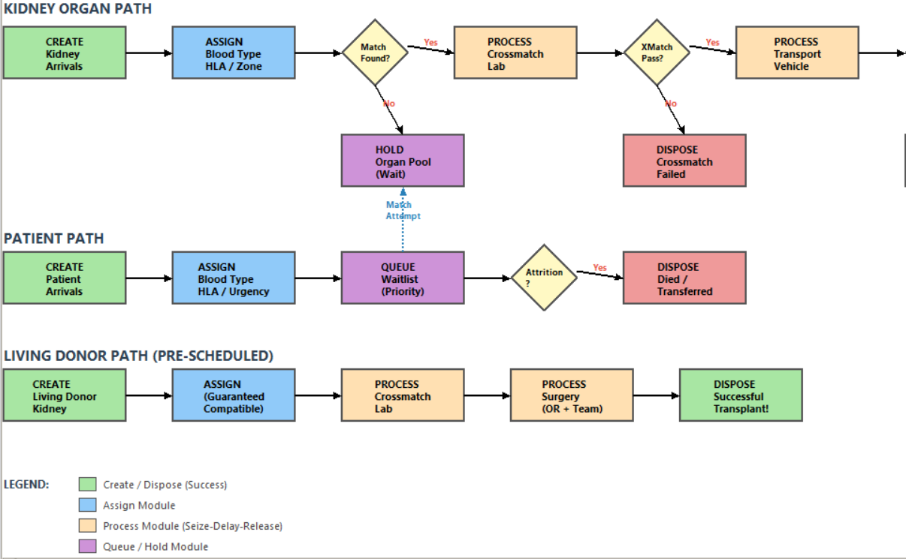

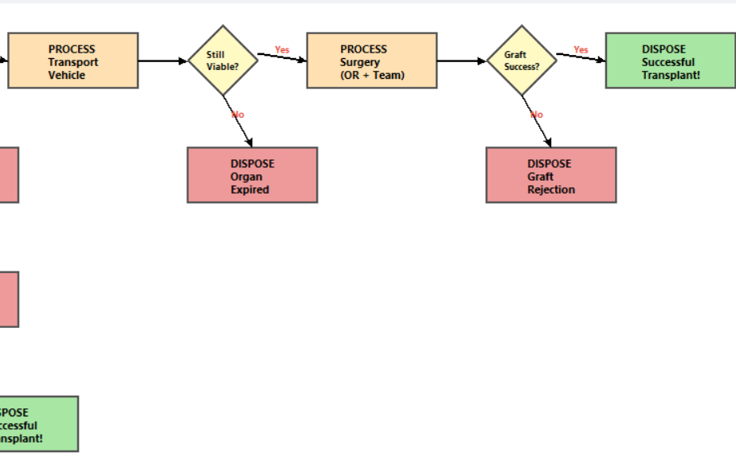

- LOGICAL STRUCTURE

The simulation's logical structure follows these key design principles:

a) TWO-WAY MATCHING TRIGGER
The matching logic is triggered in two directions:
• When a new kidney arrives → search the patient waitlist
• When a new patient arrives → search the organ pool
This prevents situations where a compatible kidney and patient both sit idle without being matched.

b) PERISHABILITY ENFORCEMENT
The cold ischemia clock runs continuously from the moment of organ harvest. Viability is checked at three critical decision points:
1. After transport (before surgery prep)
2. After surgery prep (before entering the OR)
3. Hourly in the organ pool (for unmatched kidneys)
If any check fails, the organ is immediately disposed.

c) QUALITY DECAY MODEL
Organ quality degrades exponentially: Q(t) = e^(-0.05·t), where t is hours since harvest. This quality score directly affects the transplant success probability, creating a meaningful trade-off between waiting for a better match versus transplanting quickly before quality degrades.

d) PRIORITY-BASED ALLOCATION
The matching algorithm uses a composite score to allocate organs fairly:
Score = (Urgency Weight × 10) + (Wait Days × 0.5) + (HLA Matches × 2)
This means critically ill patients and those who have waited longest receive priority, but a strong HLA match can elevate a lower-priority patient.

e) WARM-UP PERIOD
The first 30 simulated days (720 hours) serve as a warm-up period. All statistics collected during the warm-up are discarded. This ensures the system reaches a representative steady state before data collection begins, avoiding initialization bias.

f) MULTIPLE REPLICATIONS WITH DIFFERENT SEEDS
The model runs multiple independent replications (default: 10), each with a different random number seed. This enables the calculation of confidence intervals on output metrics, providing statistical rigor equivalent to Arena's built-in replication analysis.

- STATISTICS COLLECTED

The model collects three types of statistics, mirroring Arena's statistical
framework:

TALLY (Observation-Based) Statistics:
• Organ Cold Ischemia Time (hours) — time from harvest to transplant
• Organ Quality at Transplant — quality score at surgery completion
• Patient Wait Time (hours and days) — time from waitlist entry to match
• Surgery Duration (hours)
• Transport Time (hours)
• Crossmatch Testing Time (hours)
• Organ Total Time in System (hours)
• HLA Match Score (0–6) — antigen matches in successful transplants
• Patient Priority Score at Match

TIME-PERSISTENT (Time-Weighted) Statistics:
• Waitlist Length — number of active patients over time
• Organ Pool Size — number of available organs over time
• Operating Room Utilization (0–1)
• Surgical Team Utilization (0–1)
• Transport Vehicle Utilization (0–1)
• Crossmatch Lab Utilization (0–1)

COUNTER Statistics:
• Total Kidneys Arrived
• Total Patients Arrived
• Successful Transplants
• Failed Transplants (Graft Rejection)
• Organs Expired (Cold Ischemia Exceeded)
• Organs with No Compatible Match
• Patients Died on Waitlist
• Patients Transferred Out
• Living Donor Transplants

DERIVED Metrics:
• Organ Utilization Rate = Successful Transplants / Total Kidneys × 100%
• Organ Waste Rate = Organs Expired / Total Kidneys × 100%
• No-Match Rate = No Compatible Match / Total Kidneys × 100%

- INPUT DISTRIBUTIONS SUMMARY
INPUT | DISTRIBUTION
Kidney inter-arrival time | Exponential (mean = 8 hrs)
Patient inter-arrival time | Exponential (mean = 4 hrs)
Living donor inter-arrival | Exponential (mean = 48 hrs)
Crossmatch testing time | Triangular(1.0, 2.0, 4.0) hrs
Transport time (Local) | Triangular(0.5, 1.0, 2.0) hrs
Transport time (Regional) | Triangular(1.5, 3.0, 5.0) hrs
Surgery prep time | Triangular(0.5, 1.0, 2.0) hrs
Blood type | Discrete(0:44%, A:42%, B:10%, AB:4%)
HLA antigens (each of 6) | Discrete Uniform(1, 20)
Urgency level | Discrete(Crit:10%, Hi:25%, Med:40%, Low:25%)
Patient age | Uniform(18, 75)
PRA Score | Uniform(0, 100)
Transport zone | Discrete(Local:40%, Regional:35%, Nat:25%)
Organ quality decay | Q(t) = e^(-0.05 x t)
Transplant success probability | 0.95 + 0.005xHLA - 0.01xCIT, E[0.7,1.0]
Crossmatch failure probability | 0.05 + PRA/500
Patient death rate | 0.0001 per hour
Patient transfer rate | 0.0005 per hour

- SIMULATION CONTROL PARAMETERS

• Simulation Duration: 8,760 hours (365 days / 1 year)
• Warm-Up Period: 720 hours (30 days)
• Number of Replications: 10 (each with a unique random seed)
• Base Random Seed: 42 (seeds: 1042, 2042, 3042, ...)
• Report Interval: Every 24 hours (daily snapshots)

